# Here is what we do in the community



**WE Serve**

* Conduct and participate in various Health Fairs in the Reston/Herndon area, screening people for vision and hearing problems and other medical conditions
* Provide eye exams and eye glasses for people who cannot afford them
* Provide hearing exams and hearing aids for people who cannot afford them
* Collect and Recycle eyeglasses
* Support Youth Groups (Leos, Boy Scouts, Eagle Scout projects, etc.) in Herndon and Reston
* Sponsor a local and state-wide music competition for high school students to earn scholarships
* 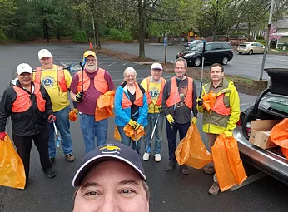Supported and taught English as a Second Language (ESL) classes
* Sponsor blind and deaf children to attend summer camps in Maryland and Virginia
* Support Special Olympics events and provide vision screening
* Semi-annual road clean-up and other environment projects
* Winter Coat Collection for the Crossroads Coat Closet
* Participate in other service projects and fundraisers throughout 14 counties in northern Virginia
* 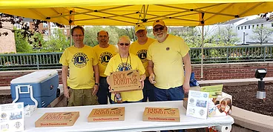Fundraiser Citrus Sale in early December in Reston
* Annual Holiday Party for members
* Annual Dinner for Installation of Officers
* Monthly general meeting, usually with a speaker on a topic that affects what we do in Reston
* Monthly board meeting, where we spend the funds collected and get status reports on upcoming projects
* 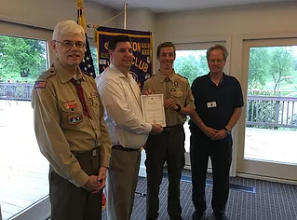And much more!

# Where funding goes in the community

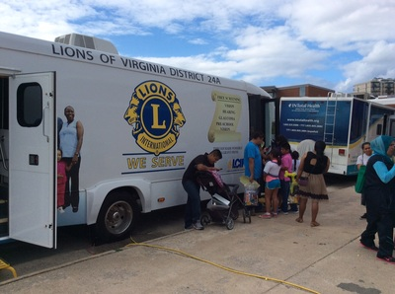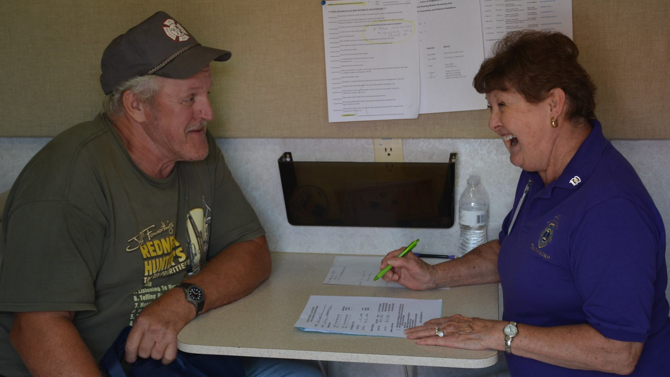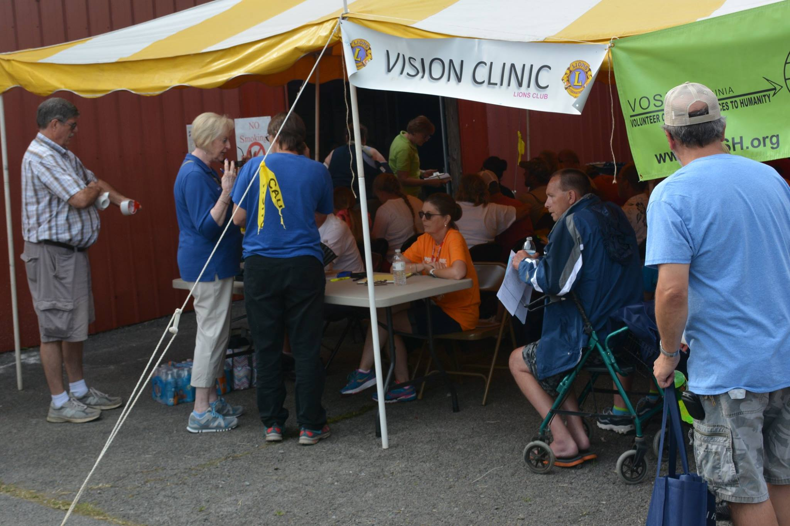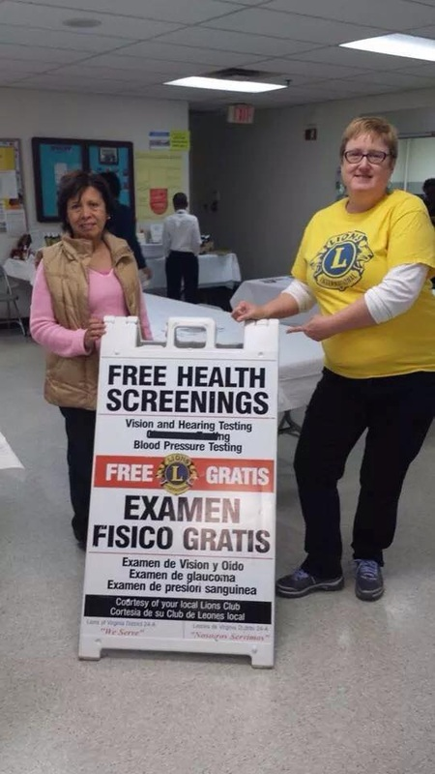

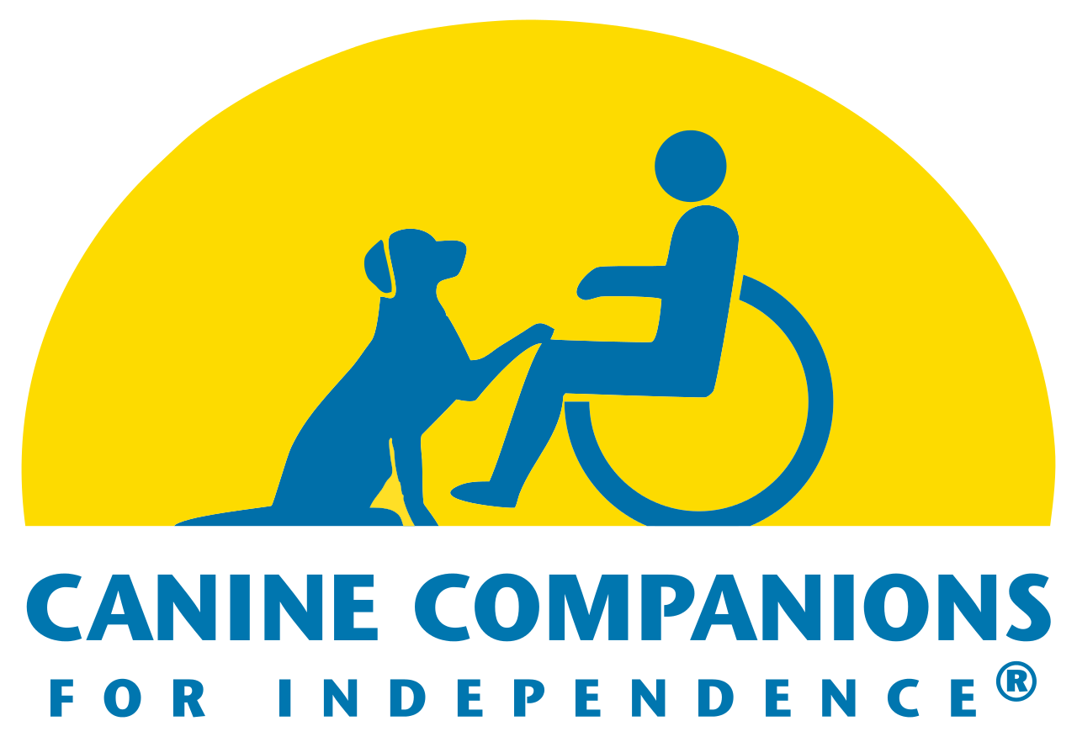 

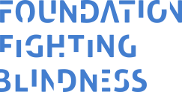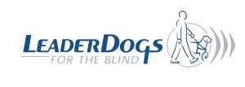

**We Serve**

* Lions Mobile Sight & Hearing Screening Van
* Hearing Aid Foundation
* Hearing restoration research at UVA
* Eye Clinic at Inova Fairfax Hospital
* Fund vision restoration research at John Hopkins and others research hospitals
* Northern Virginia Lions Youth Camp near the Shenandoah River
* Eye exams, glasses, hearing aids for individuals who cannot afford them
* Food donations to local food pantries
* Diabetes Awareness training
* Buy diabetic supplies for people who cannot afford them
* Lions of Virginia Foundation (disaster relief, special needs equipment)
* Leader Dogs for the Blind and Canine Companions for Independence
* Support for the state Eye Bank and promotion of eye donations for transplant and research
* Support Literacy by purchasing and distributing books
* Lions Clubs International Foundation (disaster relief; vision research; measles eradication; vision problem prevention through clean water, and good nutrition; build hospitals and clinics)
* Support Medical Missions to impoverished areas in the US and the world
* For more information go to our website at [www.restonlions.org](http://www.restonlions.org)

100% of the net funds collected from the public go back to the public